Project Title: Highway Driving

**The Goal of this Project**

The goal of this project us to design a path planner that can create smooth, safe paths for the car to follow along with a 3-lane highway with traffic. A successful path planner will be able to keep inside its lane, avoid hitting other cars, and pass slower-moving traffic all by using localisation, sensor fusion, and map data. The Car velocity was as close as possible to 50mph even though it does vary at some point. The code compiles correctly, as I included the Spline library and a helper function from (<https://github.com/udacity/CarND-Path-Planning-Project/tree/master/src>)

The car can drive at least 4.32 miles without incident.

The car was able to drive more than 4.32 miles without incident. However, on its first run, there was a collision after 4.26 miles.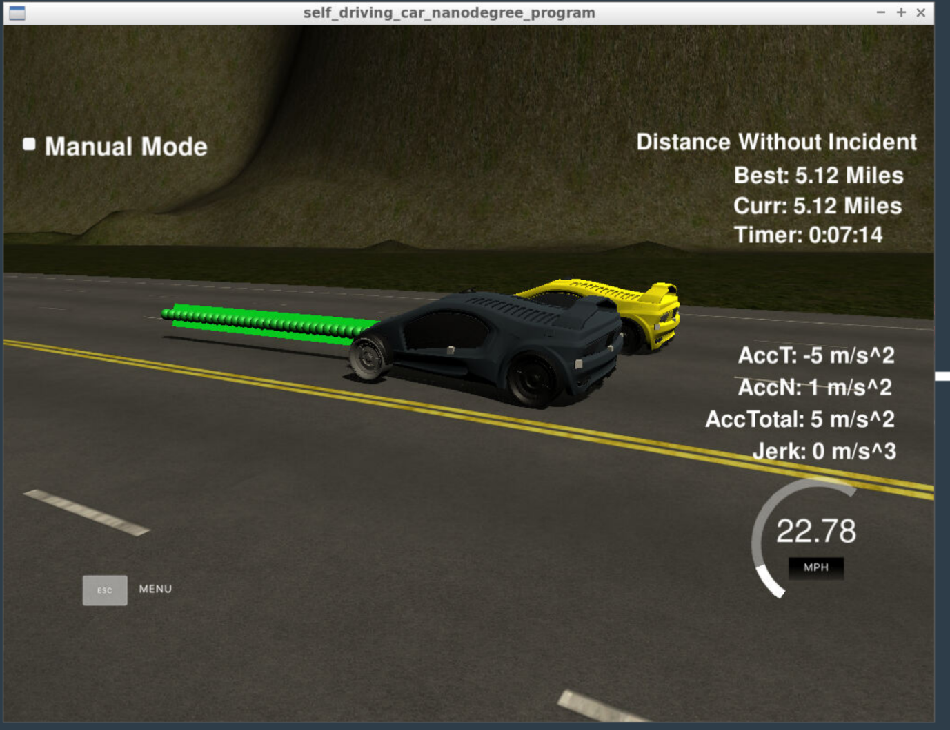

The car drives according to the speed limit-

The car was able to drive according to the 50mph speed limits. There were moments when this speed fluctuated. However, the speed limit was not exceeded.

**Max Acceleration and Jerk are not exceeded-** The max acceleration and jerk was not exceeded

**The car stays in its lane, except for the time between changing lanes-** The car stayed in the lane on the right side of the 3 lanes except for when it is performing a change lane manoeuvre.

**The car is able to change lanes –** The car was able change lane, only when the car ahead is slow and it is slow to do so.

**Prediction – 116 -152**

This part utilised the sensor fusion in predicting of other cars around us when in a lane or attempting to perform a manoeuvre

**Behaviour – 154 – 177**

This part determine the behaviour of the car based on information from the prediction (telemetry and sensor fusion). The car decides whether to remain on the same lane, speed up, slow down or attempt a lane change manoeuvre.

**Trajectory – 179 – 278**

This part estimate the car trajectory based on the decision from the behaviour.